Words to Know
Fill in this table as you work through the lesson. You may also use the glossary to help you.
Warm-Up Introduction to the Volume of a Cylinder
?
W2K
Lesson Question
for volume.
a cylinder.
a cylinder.
of
Generate the
of
Calculate the
Identify
Inspect the volume of a cylinder.
Lesson Goals

a solid figure with two congruent circular or elliptical bases connected to a curved side
the measure of the amount of space occupied by a three-dimensional solid object
a segment that extends from the center of a circle to any point on the circle
a chord that passes through the center of a circle
to take the place of; to replace

Slide
base
base
.
and
bases that are congruent
A cylinder is a solid figure with
Identifying Parts of a Cylinder
In a cylinder the bases are circular shapes.
Base
height
- Not a Base
Base Versus Not a Base
- Base
Base
2

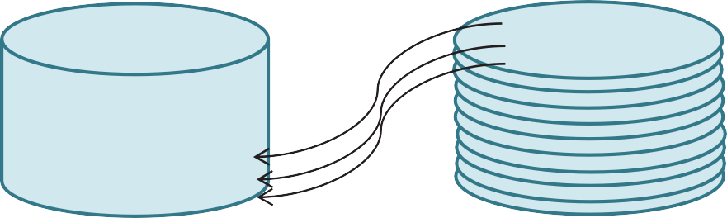
4
.
We know that the area of this circle is
= Bh
V =
×
Volume = Area of
Height
r =
Base
The Volume Formula
Slide
The Volume of a Cylinder
How is the volume of a cylinder measured?

V =

Where, B = base

Area

h

Slide
When we leave the π symbol in the answer, it is the exact value.
in.3
V =
B = 9π in.2
2. Simplify to find the volume.
7 in.
V = Bh
V = ( )( )
.
Use the formula to calculate the volume of the cylinder.
V = Bh
Follow the steps to find the volume.
1. Substitute the given measures for the corresponding
Using the Formula to Calculate Volume
PROCEDURE
7
9
ft3
.
)
)(
)3
V = π(
V = π(
V =
What is the volume of a cylinder with a
radius of 5 feet and a height of 3 feet?
Cylinder V = Bh V =
Follow the steps to find the volume.

- Substitute the given measures for the corresponding variables.
- Simplify to find the
Finding Volume Given Radius and Height
EXAMPLE

Slide

Determining Volume Given the Diameter
EXAMPLE

Consider this cylinder and the given diameter of the circle base.

16 in.

d = = r
2

6 in.

12

What is the volume of the cylinder?
Cylinder V = Bh

V =
V = π( )( )
V = π( )6
V = in.3

Summary
Lesson Question
??

How can you find the volume of a cylinder?
Lesson Question
Answer
Introduction to the Volume of a Cylinder

Use this space to write any questions or thoughts about this lesson.

