?
W
2K
Lesson Question
Words to Know
Fill in this table as you work through the lesson. You may also use the glossary to help you.
Use a given height with either the
or diameter measure.
of a cone.
Apply the formula to find the volume
of a cone.
Determine the
formula for the
Investigate a relationship between cylinder
and cone volumes.
Lesson Goals

a segment that extends from the center of a circle to any point on the circle
to explain or show the similarities or differences between items or ideas
the measure of the amount of space occupied by a three- dimensional solid object
a solid object with a circular base and one vertex
a chord that passes through the center of a circle

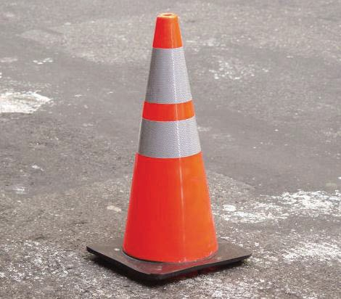

Circular Base Area
This construction cone has a radius of 7 inches. What is the area of the base?

A =
A = π(7)2
A = π(7)(7)
7
A = in.2

Slide
Identifying Parts of a Cone
Parts of a cone
- Base
- Center of base
- Vertex

of base
2
radius
base
vertex
Height
Diameter
Radius
•
•
•
Measurements of a cone

Slide
)2
A = π(
= 4π units sq.
2
5
5
units sq.
A =
2
Relating a Cone to a Cylinder
Consider a cone and a cylinder with the same height and radius.
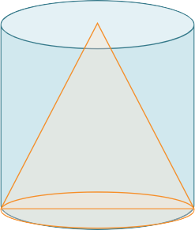
4
.
same base area and
greater volume even though they have the
would actually have the
The
Comparing Cylinder and Cone Volumes
EXAMPLE
Compare the volume of each when a cone and a cylinder have the same base area and height.

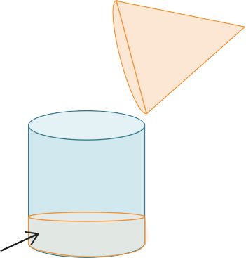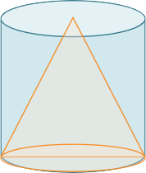Slide
1
3
⎠
⎝
Volume = ⎜ ⎟ (Volume of cylinder)
Comparing Cylinder and Cone Volumes
EXAMPLE
4
6
V =
1
1
Volume of a Cone:
(Volume of the cylinder)
3

V = 3 Bh
of the
- B is the circular base
- h is the height
•
- Volume of a cylinder: V = Bh
Determining a Formula for the Volume of a Cone

Slide

Calculating the Volume of a Cone

What is the volume of a cone with a radius of 2 meters and a height of 5 meters?

1
Formula: V = 3 Bh

V = 1 πr2h
3
V = 1π(22)( ) 3
5 m
V = 1π( )(5)

3
2 m

V = 1 π(20) 3
8

V = m3
Using the symbol for π
gives an exact value.

Slide

Determining the Volume of a Cone for a Given Diameter
A cone has a diameter of 12 inches and a height of 15 inches. What is its volume?

1
10
- V = 3 Bh
V = 1 πr2h
3
V = 1 π(62 )(15) 3
V = 1π( )(15)

3
V = 15 π(36) 3
V = 5π(36)

V = in.3

= r

12 in.

15 in.

Summary Introduction to the Volume of a Cone
?

How do you find the volume of a cone?
Lesson Question
Answer

Use this space to write any questions or thoughts about this lesson.

