D. ordered based on time
synthesize
C. to show using an example or a visual
chronological
B. to bring together parts into a whole
conclusion
A. a judgment or inference based on evidence
illustrate
Words to Know
Write the letter of the definition next to the matching word as you work through the lesson. You may use the glossary to help you.

Synthesizing Ideas in an Informational Text
?
W2K
Interpret information
from charts and graphs.
Synthesize information from different
.
Understand
chronological
in an informational text.
Lesson Goals

Read from When Birds Get Flu and Cows Go Mad! How Safe Are We? by John DiConsiglio.
Lesson Question
Warm-Up

Slide
2

Sorting Information

Writers often sort information to help readers different parts of a text through:

- pictures or diagrams.

- numbered sections.

- .

- graphs or charts.

- maps.

- or separated sections of text.

Slide

Information Sorted by a Keyword Graphic Organizer

The Disease Hunter’s Toolbox

GOGGLES MASKS

BIOHAZARD SUIT
GLOVES

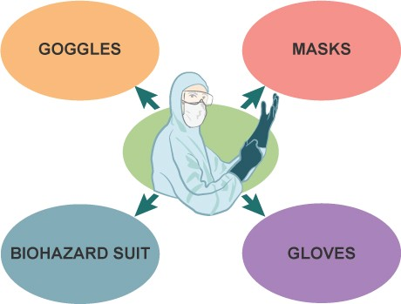
2

Information can be sorted by keyword , using a graphic organizer.

In this presentation style, an essential point or image is annotated with different pieces of information.

Slide

Information Sorted by Numbering
Numbering can be used in an informational text to:

- show order, or time-based order.

- show the steps of a process.

  - information.

2. 1957
Asian Flu Asian flu caused 70,000 deaths in the United States.

1996 A Bad Burger
The first human death from BSE was recorded.

6. 1997
When Birds Get Flu In Hong Kong, bird flu was found in humans.

4
1910 1960 2010

1. 1918 | 3. 1968 | 4. 1986 | 7. 2003
The Superbug | Another | Don’t | And Cows
The Spanish flu | Pandemic | Eat the | Go Mad!
killed 40–50 million | The Hong | Meat | The first US
people. | Kong flu | BSE was | case of
 | killed 34,000 | first | mad
 | Americans. | diagnosed | cow
 |  | in Britain. | disease
 |  |  | occurred.

Slide

Numbers Used to Divide Information

7
Don't worry about mad cow disease. But pay attention to E. coli.
Here's how you can protect yourself from it.

1)
Wash Your Hands Carefully
2)
Don’t Cross-Contaminate
3)
Keep Hot Foods Hot
4)
Keep Cold Foods Cold
5)
Wash Fruits and Vegetables
–When Birds Get Flu and Cows Go Mad!,
John DiConsiglio

This selection is numbered in order to divide information into different
.

Slide

Interpreting a Graph

Charts and graphs are ways to present information that show different kinds of data at once.

HIV/AIDS IN AFRICA, 1958–2003
The deadly disease has been dramatically shortening life expectancy.

65 Botswana South Africa
60

Kenya
55
Life Expectancy

Zimbabwe
50

45

40

35

30
1958 1963 1968 1973 1978

1983 1988 1993 1998 2003

Year
9

The graph allows you to quickly the countries.

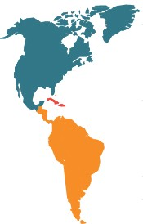Slide
11

Interpreting a Map

Maps information by showing it in a visual way. This map includes:
  - a title.

  - .

  - supporting text.

HIV AROUND THE WORLD (2006)

North America
Adults and children living with HIV:
1.4 million
Adult and child death due to HIV: 18,000
Caribbean
Adults and children living with HIV: 250,000
Adult and child death due to HIV: 19,000
Latin America
Adults and children living with HIV:
1.7 million
Adult and child death due to HIV: 65,000

Slide
2

Synthesizing Information
To synthesize information, put together different pieces of information.

  - This allows you to draw , or judgments or inferences based on evidence, about the text as a whole.

To :

  - Read a section, then stop and think about what you know.

  - Decide what the central ideas are.

  - Think about how the text to you, other texts you have read, or the world.

  - Use your own words to reflect on what you have learned and to generate new ideas.

Slide

Synthesizing Information by Connecting Text to Text
When information about similar ideas is presented in different formats, you can make text-to- connections between the ideas in the whole text.

2
The Disease Hunter's Toolbox Gloves
Doctors and scientists use different types of gloves. Surgical gloves help keep a wound sterile – free from dangerous germs and bacteria. Examination gloves prevent contamination or infection when
treating a patient.
Fear of Food?
- Wash Your Hands Carefully
Proper hand washing can get rid of almost half of all foodborne illness. . . .
- Don't Cross-Contaminate
When raw meat comes in contact with other foods, it can cause cross-contamination. Don't use the same utensils for meat and other foods. And
be sure to wipe down countertops and cutting boards.

The second text to the first in that it also shows methods for how to avoid contamination and spreading disease.

Synthesizing Ideas in an Informational Text
How do you put together information presented in different formats?
Lesson Question
?
Answer
Summary

Use this space to write any questions or thoughts about this lesson.

