?
W2K
Lesson Question
Words to Know
Fill in this table as you work through the lesson. You may also use the glossary to help you.
Contrast pioneer species and climax communities.
succession.
Compare primary and
Explore ecological succession.
Lesson Goals

climax community | the final stage of succession in which a community is
lichen | a and an alga (or bacterium) growing together in a mutualistic relationship
pioneer species | the first species to an uninhabited area
primary succession | the gradual introduction of species in an area where no or organisms exist

W2K
things
and
An ecosystem is made up of all of the that interact in a particular area.
•
in a particular area.
Communities and Ecosystems
- A community is all the populations living
Words to Know

secondary succession | the gradual change in the species of an area after a
succession | the gradual in the types of species that live in a community

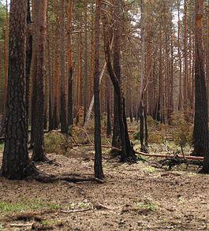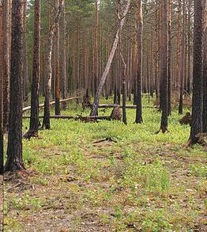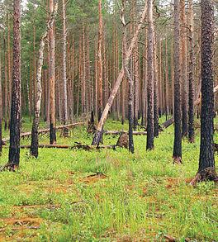Slide
Succession
Succession is the gradual change in the types of
that live in a
.
One year later
years later
Three years later
2
Primary Succession
Primary succession is the gradual
of species in an area
where no
or
exist.

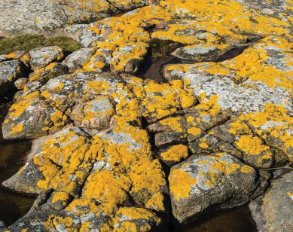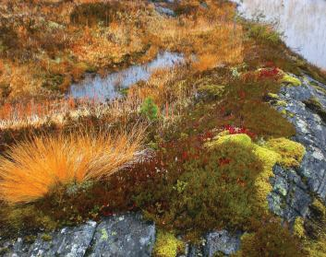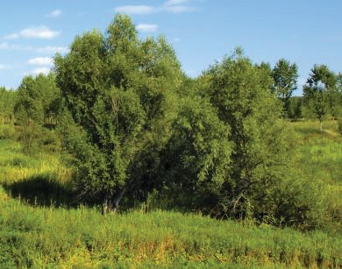Slide
Step 3: New plants grow and add

to
the soil.
introduced.
, are
Step 2: Pioneer species enrich the soil.
Step 1:
species, like
main steps to primary succession.
There are
Primary Succession
4
7
succession.
quicker than
- Because of this starting point, secondary succession happens much
.
previous plants or animal species
is disturbed but some of the
.

- It occurs when an
a
Secondary Succession
Secondary succession is the gradual change in the species of an area after

Slide
disasters
- Environments struck by
- Clear-cut
- Unused farms
areas
- Deserted
and parks
- Abandoned
Environments of Secondary Succession

climax community.
stage of succession in which a community is stable is called a
The
Climax Community

Pioneer Species vs. Climax Community

Pioneer Species

Climax Communities

- Mark the start of primary succession
7
10

- Consist of one or two

- Have a small body size

- Have a large number of
- Mark the end of both types of
- Consist of many species

- Have a large body

- Have a small number of offspring

Slide

What is ecological succession?
Lesson Question
?
2
Answer

Review: Key Concepts

Primary Succession
- The series of changes is predictable.

- Events like volcanic eruptions are causes.

- Soil does not exist.

- does not exist
and requires pioneer species.

- Changes are slow.

- The end result is a community.

Secondary Succession
- The series of changes is

.

- Events like forest fires are causes.

- Some soil is present.

- Some remains of the previous community are present.

- Changes are quicker than in

succession.

- The end result is a climax community.

Slide
2

Review: Key Concepts

Pioneer Species

  - Mark the of primary succession
  - Consist of one or two species

  - Have a body size

  - Have a large number of offspring

Climax Communities

- Mark the of both types of succession
- Consist of many species
- Have a large body size
- Have a small number of offspring

Use this space to write any questions or thoughts about this lesson.

