C. a process that involves the collection of information and ideas supported
by belief or opinion
_____ objective
B. a process that involves the collection of information and ideas supported
by evidence
_____ pseudoscience
A. based on facts instead of opinions or beliefs
_____ science
Words to Know
Write the letter of the definition next to the matching word as you work through the
lesson. You may use the glossary to help you.
Lesson Question
?
W
2K
possess.
that
Recognize the characteristics
.
science.
distinguish it from
of
Identify the
and
Define
develops.
Explain how
Lesson Goals

F. based on opinions or beliefs instead of facts
_____ systematic
E. using a careful method
_____ scientific knowledge
D. the information that is gathered by the systematic study of nature
Words to Know
_____ subjective
W
2K
The Learning Process
Fill in the steps of the learning process.

The Learning Process

Slide
nature.
gathered by the systematic study of
Scientific knowledge:

- is the
.
- is supported by
.
- involves the collection of
.
- Involves observation and
process.
Science
Science:

- is a
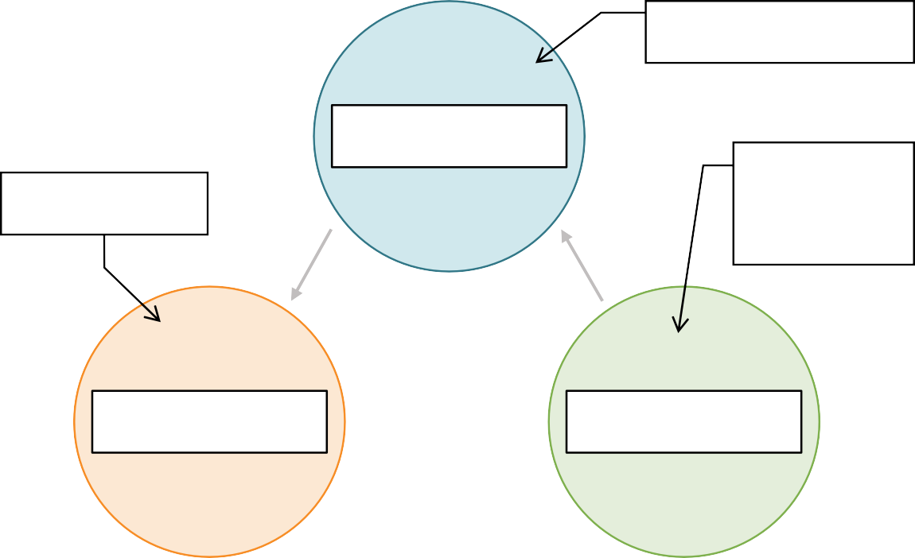
2
Conclusion made from the facts
Data collected
Way to collect facts
Science: A Cyclical Process
Fill in the steps of the cycle of science.

Slide
candling
•
effect
Examples:

- The
Explanation
•
.
supported by belief or
Pseudoscience
Pseudoscience:
- is a process that involves the collection of information and ideas
4
Science vs. Pseudoscience  Science | Pseudoscience
- Relies on process  - Is  - Is constantly | - Lacks process  - Is  - Is to new  information

7
9
.
- Experimentation leads to changes in scientific
.
- The hypothesis can be tested through
.
- A scientific question may lead to a
.
- An observation may generate a scientific
Observation of the Natural World
- Scientific knowledge develops through making about the natural world.
and thinking logically
- Skeptical–requiring
to solve problems
- Creative–using
at the natural world
- Observant–taking a
about the natural world
Characteristics of Scientists

- Curious–asking
Slide
Words to Know

an act of recognizing and noting something by using the senses
a possible explanation of or answer to a scientific question that is based on prior knowledge or research, and is testable

11
14
.
- Repeat
.
- Use
trials.
•
observations.
Repeated Experimentation

- Make
of a system
- Equipment

•
- Other concerns
•
- Complexity
Practical Limitations

- Time
Slide
- Advancements in technology often lead to new scientific

.
.
they cannot directly
to make observations of things
- Scientists rely on
The Use of Technology

Slide
- Acknowledge
- Create
over time
- Conduct
Practical Solutions

- Limit
14
Ethical Limitations
Ethical controversy:

- Testing on

- Testing on laboratory

How does scientific knowledge develop and progress?
Lesson Question

Slide
?
experimentation.

- limited by time, money, equipment, size, complexity, etc.
through observation and
- builds scientific
- is conducted by curious, observant, creative, and

scientists.
.
by
Review: Key Concepts

Science:

- is a process that involves the collection of information and ideas supported
Answer
2

Slide
.
and
supported by
Review: Key Concepts

Pseudoscience:

- is a process that involves the collection of information and ideas
2

Use this space to write any questions or thoughts about this lesson.

