.
of different types
of scientific investigations.
in a scientific
investigation.
.
and
and
Differentiate
between the three types of
that can be answered through scientific
investigation.
Summarize the
Distinguish
between
Identify
.
Describe the process of
Lesson Goals
Lesson Question
?
W
2K
Words to Know
Fill in this table as you work through the lesson. You may also use the glossary to help you.

a question that is based on observations and can be
answered through an investigation
any process used to ask and answer questions
about the natural world
a possible explanation of or answer to a scientific
question that is based on prior knowledge or research and is testable

Science
Science:

- is a way of about the .

- can take place .

- can be practiced by .

- involves making and .

Slide
- Is not just for scientists
and
- Uses similar
- Involves different
the natural world.
is any process used to ask and answer questions about
Scientific Inquiry
2
results.
•
.
- providing
.
- collecting
.
- performing
.
- asking a
Scientific Inquiry: What It Involves
Scientific inquiry involves:

Words to Know
Fill in this table as you work through the lesson.
Slide
tested.
, or possible explanation, that can be
- may lead to a
.
in
- addresses a
.
A good scientific question:

- has a
.
answered through an
and can be
is based on
A
Scientific Questions
4
7
a group of related objects that interact and form a
complex whole
the part of an experiment that does not receive the
factor being tested and is used to compare results
the variable that is measured and affected during the experiment, and is “dependent” on the
independent variable
the variable that is changed by the researcher

Slide
Scientific question Procedure
Conclusion
, but not
Making
• Include:
•
•
•
form a complex whole
, related objects that interact and
Descriptive Investigations

Involve collecting data about a
7
- would not compare these fossils to other fossils of other organisms.
from the past,
- In a descriptive investigation of the paleontologist:
  - would describe the features of fossils.
- In a descriptive investigation of information gathered by the

, the scientist:
  - would obtain observations and data from the surface of Mars.
  - would not compare the observations of Mars to observations of other planets.
Descriptive Investigations: Real-World Connection
- In a descriptive investigation of behavior of male during mating season, the scientist:
  - would record their observations about the seal’s behavior.
  - would not compare the seals’ behavior to those of other seal species.

Slide
measured and affected during the experiment

- Procedure

•
, or the variable that is
researcher, and
, or the variable that is changed by the
Comparative Investigations
Involve collecting data for Include:
- Scientific

- Hypothesis

•
7
which is close to neutral and can be used in a consumer product.
of various substances to determine
3) A chemist may compare
, at different
2) A volcanologist retrieves samples from
localities and times, to compare the compositions
of suspects to the DNA
1) A forensic scientist can compare the
found at a crime scene.
Comparative Investigations: Real-World Connection

Slide
7

Experimental Investigations

Involve experiments to gather that supports or refutes a
[hypothesis]
Include:

- Scientific

- Hypothesis

- Independent and dependent

- , or the part of an experiment that does not receive the factor being tested and is used to compare results
•

- Conclusion

Comparative
Experimental
Comparison of Types of Scientific Investigations
Label each column with the type of scientific investigation being described.
Slide
reach completion. The control group is the same reaction with no catalyst.
it takes for the reaction to
reactions will have an effect on the
3) A chemist wants to determine if adding a catalyst to various chemical
can be determined by taking careful seismic measurements. The control group is measurements taken without the instruments on the Moon’s surface to make
sure the instrument is not detecting false signals.
of Earth’s Moon
2) An astronaut tries to determine if the
Experimental Investigations: Real-World Connection

1) A scientist devises an experimental investigation to explore whether the

affects plant growth. The control group is the plant that

has no colored filter.
7
14
Question | ✓ | ✓ | ✓
Hypothesis |  | ✓ | ✓
Variables |  | ✓ | ✓
Control group |  |  | ✓
Procedure | ✓ | ✓ | ✓
Conclusion | ✓ | ✓ | ✓

information
control
16
Limitations of Scientific Investigations
 | Descriptive investigations | Comparative investigations | Experimental investigations
 | - Cannot show cause- and-effect  - Give results that can  over  time  - Are repeatable | - Show a relationship that does not always indicate cause and effect | - Can lack  - Can often occur in a  setting

Slide
Benefits of Scientific Investigations
Descriptive investigations | Comparative investigations | Experimental investigations
- Are  expensive and less  - Provide a large amount of | - Provide large amounts of  - Use a wide range of | - Are best for cause- and-effect  - Allow for  of variables  - Can be repeated

How do scientists conduct scientific investigations?
Lesson Question

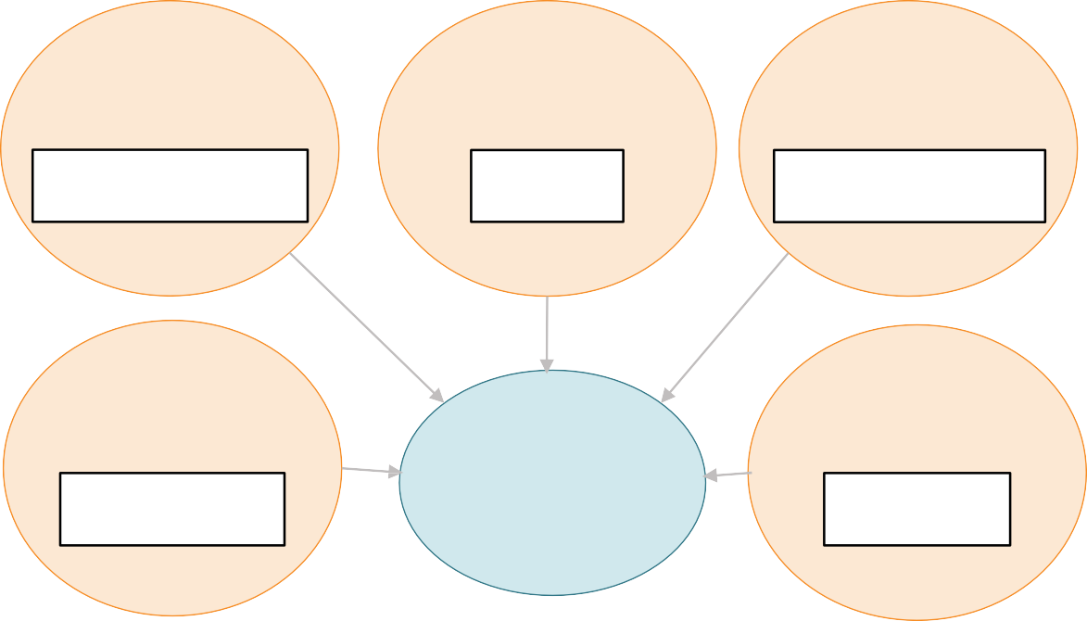Slide
?
Scientific
inquiry
Communicating
Asking
Providing
Collecting
Performing
Review: Key Concepts
Complete the graphic organizer summarizing the processes and practices of scientific inquiry.
Answer
2

Slide
supports or refutes a hypothesis
to gather evidence that
not comparisons
- Comparative

  - Collecting data for
- Experimental

  - Performing an
, but
and making
- Collecting
The three types of scientific investigations are:
- Descriptive
2

Use this space to write any questions or thoughts about this lesson.

