Lesson Question
?
W
2K
energy in a system.
in a moving system.
energy in a system.
Calculate the
Explain how energy is
Calculate the
Explore the between potential

energy and kinetic energy.
Lesson Goals
- the stored energy an object has due to its position
- a change in form, appearance, nature, or
characteristic
kinetic energy

potential energy
B. a group of related objects that interact and form a
complex whole
transformation
A. the energy an object has due to its motion
system
Words to Know
Write the letter of the definition next to the matching word as you work through the lesson. You may use the glossary to help you.

Energy

- Energy is the ability to do .

- Work involves the of energy from one object to another.

- Energy exists in several .

  - Chemical

•

  - Mechanical

•

•

  - Kinetic

Slide
and position
- The amount of each form of energy depends on the
of an object.
is the energy an object has due to its motion.
•
is the energy an object has due its position.
•
at the same time.
- Objects can have more than one form of
Potential Energy and Kinetic Energy
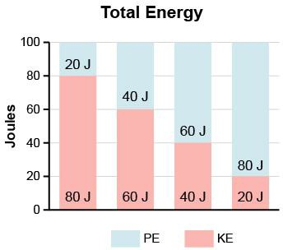
2
- The in a system stays the same.

  - If potential energy increases, then kinetic energy

.

  - If potential energy decreases, then kinetic energy

.
is the group of objects that interact with each other.
A
Total Energy

5
, h.
- an object’s
, g.
- the acceleration due to
𝑃𝐸 = 𝑚𝑔ℎ
, m.
- an object’s
The Potential Energy Equation

- Gravitational potential energy is directly related to:
PE = (150 kg)(9.8 m/s2)(25 m) =
m/s/s.
Gravity on Earth is a constant of
An Application of the Potential Energy Equation
What is the potential energy of a 150 kg rock resting on top of a hill that is 25 m high?
Slide
potential energy.
its gravitational
- The greater the height of an object, the
.
potential energy.

- Gravitational potential energy comes from the presence of
of an object is known as gravitational
- Potential energy related to the
energy.
- Potential energy is
Gravitational Potential Energy

Slide

The Potential Energy Equation

When potential energy is known, or can be found.

7

𝑃𝐸 = 𝑚𝑔ℎ

To find mass, rearrange equation: 𝑚 = 𝑃𝐸/𝑔ℎ

To find height, rearrange equation: ℎ = 𝑃𝐸/𝑔𝑚

Example: Jeremiah, who has a mass of 60 kg, starts skating down a hill with a potential energy of 1,200 J. What is the height of the hill? Round your answer to the nearest whole number.
Step 1: Identify what is known.

  - 𝑚 =

  - 𝑔 = 9.8 m/s/s

  - 𝑃𝐸 =

Step 2: Multiply mass x gravity.

60 kg × 9.8 m/s/s = kg m/s/s

Step 3: Solve the equation.

ℎ = (1,200 J)/588 kg m/s/𝑠 =

Step 4: Round the answer to the nearest whole number.

ℎ = 2.04 m = m

Slide
increases
- Increases when
increases
- Increases when
- depends on the mass and velocity of an object.
.
Kinetic Energy
Kinetic energy:
- is the energy of
10
, J.
Multiplied together give us
.
Velocity squared (v 2) is measured in
.
Mass (m) is measured in
2
𝐾𝐸 = ¹𝑚𝑣2
.
an object’s velocity, v,
an object’s mass, m, times
- Kinetic energy is directly related to
The Kinetic Energy Equation

Slide

An Application of the Kinetic Energy Equation
Example: What is the kinetic energy of a 55 kg girl walking at a velocity of 2 m/s? Step 1: Identify what is known.
- 𝑚 =

- 𝑣 = w m/s

Step 2: Find half of 55 kg.

55 kg/2 = kg

Step 3: Square the velocity

m/s × m/s = m2/s2
2

10

Step 4: Solve the equation.
KE = 27.5 kg × 4 m2/s2 =

Imagine that the girl’s velocity increases to 4 m/s. Her kinetic energy increases to .

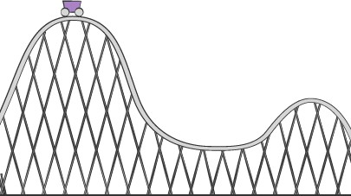Slide
12

Potential and Kinetic Energy Transformations

- PE and KE goes through , or changes

  - Top of the hill = all energy

  - Downhill = potential becomes

  - On the ground = kinetic energy

  - Uphill = kinetic becomes

What is the relationship between potential and kinetic energy?
Lesson Question

Slide
?
Review: Key Concepts
- Gravitational potential energy the ground.
as an object gets closer to
- At the same time, kinetic energy increases because the object is

up.
Answer
2
Term | Definition | Affected by | Equation
Kinetic | Energy of |  | 𝐾𝐸 =
Potential | Energy due to |  | 𝑃𝐸 =

Use this space to write any questions or thoughts about this lesson.

