?
W
2K
Apply Newton’s

to momentum.
.
.
Explain how momentum is
Define and calculate
Lesson Goals
Lesson Question
Words to Know
Fill in this table as you work through the lesson. You may also use the glossary to help you.

a quantity that has both a size and direction
the total momentum of all interacting objects is the same before and after an event
the measure of the motion of an object found by multiplying the object’s mass and velocity

Newton’s Third Law of Motion

- Newton’s of motion states that forces come in pairs that are equal in strength and opposite in direction.
- Man on car ←→ Car pushes on man

- Ball pushes on racket Racket pushes on ball

- Books push on desk ←→ Desk on books

Slide
- Units: kg • m/s
: a quantity that has both a size and direction.
•
- is the measure of the motion of an object found by multiplying the object’s mass and velocity.
  - Symbol: 𝑝
𝑝 = 𝑚𝑣
Momentum
2
Solve the equation:
- 𝑝 = mv = (2 kg)( 0.8 m/s)
• 𝑝 = 1.6 kg • m/s
to use: 𝑝 = 𝑚𝑣
•
: 𝑝
•
- 𝑀 = 2 kg
- 𝑉 = 0.8 m/s
:
•
Momentum of a Hammer
EXAMPLE

What is the of a 2 kg hammer swung at 0.8 m/s?

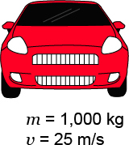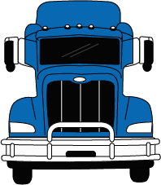
4
7
momentum of interacting objects does not change.

𝑝𝑖 = 𝑝𝑓
states that the total
- The
Law of Conservation of Momentum
Slide
will have the greater momentum.
, the object with the greater mass
velocity will have the greater momentum.

- If two objects have the same
, the object with the greater
- If two objects have the same
Mass, Velocity, and Momentum

Equal Momentum

Car:
- 𝑝 = mv
- 𝑝 = (1,000 kg)(25 m/s)
𝑚 = 1,000 kg
• 𝑝 = kg • m/s 𝑣 = 25 m/s
Truck:
- 𝑝 = mv
- 𝑝 = (5,000 kg)(5 m/s)

• 𝑝 = kg • m/s

𝑚 = 5,000 kg
𝑣 = 5 m/s

Slide

Collisions in Which Objects Stick Together

- Two or more objects collide and to become one object with one velocity.
  - They individual masses .

  - All objects have the .

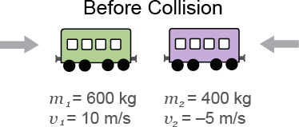
9

Before Collision  Green train car:  - 𝑝 = mv  - 𝑝 = (600 kg)(10 m/s) | Purple train car:  - 𝑝 = mv  - 𝑝 = (400 kg)(−5 m/s)
• 𝑝 = kg • m/s | • 𝑝 = kg • m/s
Total momentum before collision:  • 6,000 kg • m/s + (−2,000 kg • m/s)  kg • m/s | Before Collision  𝑚1 = 600 kg 𝑚2 = 400 kg
 | 𝑣1 = 10 m/s 𝑣2 = −5 m/s
After Collision
Total momentum after collision: | After Collision
- 𝑝 = mv
- 𝑝 = (1000 kg)(4 m/s)
= kg • m/s | 𝑚𝑓 = 1,000 kg  𝑣𝑓 = 4 m/s

Slide

Collisions in Which Objects Bounce Apart

- Two or more objects collide together and with separate velocities.
  - They their original masses.

  - The velocities may .

Before Collision
Green train car:
    - 𝑝 = mv
    - 𝑝 = (600 kg)(2 m/s)

• 𝑝 = kg • m/s

Purple train car:
- 𝑝 = mv
- 𝑝 = (400 kg)(‒4 m/s)

• 𝑝 = kg • m/s

Total momentum before collision:

• 1,200 kg • m/s + (‒1,600 kg • m/s) =

kg • m/s

After Collision
Green train car:
  - 𝑝 = mv
  - 𝑝 = (600 kg)(−2 m/s)

• 𝑝 = kg • m/s
Before Collision

𝑚1 = 600 kg 𝑚2 = 400 kg
𝑣1 = 2 m/s 𝑣2 = −4 m/s

Purple train car:
- 𝑝 = mv
- 𝑝 = (400 kg)(2 m/s)

• 𝑝 = kg • m/s

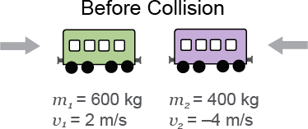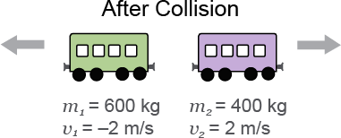
9
Total momentum after collision:

• −1,200 kg • m/s + (800 kg • m/s)

= kg • m/s

After Collision

𝑚1 = 600 kg 𝑚2 = 400 kg
𝑣1 = −2 m/s 𝑣2 = 2 m/s

Slide
12
14
the momentum of the cannonball moving right.)
𝑚𝑐𝑏𝑣𝑐𝑏 (The momentum of the cannon moving left equals
- 𝑚𝑐(−𝑣𝑐)
cannonball ←→ Cannonball pushes cannon
- Cannon
.
- Newton’s third law describes action and reaction
momentum.
of motion can be applied to the conservation of
- Newton’s
Newton’s Third Law of Motion and Momentum
of a collision.
the
- Reducing the force exerted by action-reaction force pairs is done by extending
damage.
- Minimizing the force exerted in action-reaction force pairs
.
- Faster objects require greater changes in momentum to
or transferring momentum requires a force.
•
Force, Momentum, and Collision Time

What is momentum?
Lesson Question

Slide
?
the collision increases.
exerted on an object during a collision decreases if the time of
- The
in momentum.
- Forces cause
that objects will also have equal and opposite momenta when momentum is

conserved.
of motion about action and reaction forces means
- Newton’s
momentum of all objects in a collision or explosion must be the same before and

after the collision or explosion.
states that the total
- The
𝑝 = 𝑚𝑣.
is the product of an object’s mass and velocity, found by the
•
Review: Key Concepts
Answer
2

Use this space to write any questions or thoughts about this lesson.

