The High Price of War
Each side thought it would win a quick victory.
The battles at Bull Run and Antietam proved this assumption
.
both sides during the war.
challenges facing
and
- Compare the
front.
on the front lines and on the home
- Identify the role of
of soldiers on both sides.
- Compare the
Lesson Objectives

By the end of this lesson, you should be able to:

 | Casualties | Casualties | Outcome
(August 1862) | 13,380
(Sept. 1862) | 12,400 | 10,300

W
2K

Words to Know
Fill in this table as you work through the lesson. You may also use the glossary to
help you.

Term | Definition
draft | to force people to join an
habeas corpus | the part of the Constitution that protects  from
inflation | an in

?
Lesson Question
Slide
the army paid them to fight
- Needed the
- Had never been away from home

- Saw going to war as an
.
Many were
.
Why Union Soldiers Volunteered

Most Union volunteers were
2
in camp.
- Soldiers were
from the living conditions.
- Soldiers often got
.
- Drinking water was often
.
- Food was provided, but it was often
.
was a little better than life on the
Life in
Daily Life in Union Army Camps

4
later in her life
- Founded the
- Served at many key battles of the Civil War
”
- Became known as the “
- Worked as a Union
Clara Barton (1821–1912)
- Many
- Greater injury from more
- Many deaths from
- No knowledge of
at best.
Medical Care

During the Civil War, medical care was
Slide
.
Some women served in combat in
.
gathered
Women on the Union Front Lines
Women served the Union in many different ways in the Civil War.

helped sick and wounded soldiers.

Slide
Problems for the Union Army

Problems for the

Unfamiliar
4
7
for the first time, viewing the war as an
leaving home
- Like Union volunteers, were mostly
, and
,
- Were defending their
.
Why Confederate Soldiers Volunteered

Many Confederate volunteers were passionate about the

Slide
killed many.
and
•
for battle.
and
were common.

- Camp life could be boring, with soldiers
•
Army camp life was hard for Confederate soldiers too.
Daily Life in Army Camps
7
helped win the Battle of Bull Run.
Spy
Confederate soldiers.
Nurses helped
Women on the Confederate Front Line

Women served the Confederacy in many different ways during the Civil War.

7
10
for the war effort
and collected
- Became more active in
, and
,
- Took care of
and
- Made
Women on the Union Home Front

When men left farms or factories to go to war, women were often left to do their

.
Slide
Problems for the Confederate Arm  The Confederate soldiers faced many  .  - They were not as  as the Union  Army.  - They had trouble getting  . | y | The Confederate Army had  as well, however.  - They had .  - They knew the  well and were to win the war.

Slide
for African American soldiers
- Collected
soldiers in the
- Fought to allow
and
- Fought for the rights of
who became a
- Was a former
Sojourner Truth (1797–1883)
10
12
as president.
his
Others thought Lincoln
.
Lincoln believed this was necessary to respond to
- Part of the Constitution that protects citizens from
.
of
In 1862, President Lincoln suspended the
Lincoln and Habeas Corpus

Slide
- Were mostly from the
the United States with
- Wanted to make peace by
the war.
who
The Copperheads were
The Copperheads
12
lasted four days.
in
The
of the draft.
could
of the Union draft.
rioted because they felt they were a
.
a branch of the
forces people to
A
The New York Draft Riot

Slide
by the end of the war.
were
- Northern
Union industries.
The war
.
, an increase in
- This caused
Rising Prices
The Union printed and borrowed a lot of money to pay for the war.
12
15
- Were helped by
- Worked in the
- Ran large
for
- Took jobs and roles they had not been
.
Women on the Confederate Home Front
When men left to go to war, women often took over the job of running

Slide
.
more
This made
to the Union
- More tried to
- More rose up against their
.
people to
inspired enslaved
The war and the
Enslaved People
15
17
.
to make
had far fewer
- The
.
from
and
from
- The blockade prevented
in 1861.
of the
Lincoln ordered a
Economic Challenges

Slide

Inflation and Food Shortages
Food shortages and inflation led to riots in the Confederacy.

Not enough

Food shortages and high prices

17
- Too few

were left on the farms.

- Enslaved workers were

.

- had

destroyed farms.

- Lack of

caused .

- Shortages

.

- Prices were already high from .

- People in some parts of the South were

.

▪

and

caused to

break out.

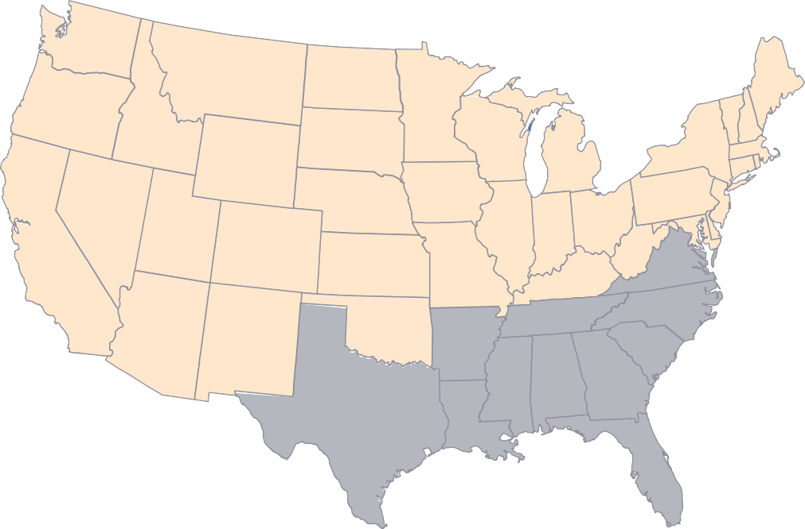Slide
17

Opposition to the War in the South

Many in the South the government.
  - Wanted to keep

  - Believed in

  - Resented the that the Confederacy created

The States

What was life like for soldiers and civilians on both sides during the Civil War?
Lesson Question
?
Answer

Slide
well.
- Union commanders did not know
.
, and
,
served as
•
.
, and
,
- Camp life meant
.
who saw war as an
volunteers were
•
Review: Union Front Lines
2
.
- had
shortages.
- had
.
- were poorly
.
- were defending their
about Southern cause.
- were
Review: Confederate Front Lines
Confederate soldiers:

Slide
increasing
•
against the
•
opposing the war
•
The Union faced problems.
.
Lincoln suspended the right of
Review: Union Home Front

did jobs on farms and in factories.
2
governments.
from some
•
.
and
•
.
- the Union
.
of
- the
Confederate challenges included:
.
and managed
worked in
Review: Confederate Home Front

Use this space to write any questions or thoughts about this lesson.

