Lesson Question
?
W
2K
.
effects on
.
.
forces and their
force on an
concept of
and unbalanced
determine the net
Describe the
between balanced
Explain how to
Distinguish
Lesson Goals
- a resistance to motion caused by two surfaces rubbing against each other
- the size or quantity of something
- a push or pull
- the support force a surface exerts on an object; always at a ninety-degree angle to the surfacea push or pull
- a quantity that has both a size and a direction
- the force that one massive object exerts to attract another object to it; expressed as the weight of an object
_____ magnitude

_____ force

_____ friction

_____ gravity

_____ normal force

_____ vector
Words to Know
Write the letter of the definition next to the matching word as you work through the lesson. You may use the glossary to help you.

Motion

- Motion is recognized when an object’s from a reference

point changes.

- Motion can be described by:

  - a .

  - a .

  - an .

Slide
Magnitude
(N).
- Forces are measured in
value.
- A vector can have a positive or
.
- A vector is indicated with an
is the size or quantity of something.
.
- A vector has both a magnitude and a
.
- Forces are
.
is a push or a
Forces

- A
2
4
is acting in and abbreviations to tell you what type of force each

vector represents.
of the force vector shows which direction the force
of the force.

- The
of a force vector represents the magnitude, or size,
- The
directions represent the magnitudes and directions of the forces acting on an object. Abbreviations are used to identify which type of force each
vector represents.
whose sizes and
Force Diagrams and Abbreviations

- A force diagram is a drawing with force

4
7
Words to Know
each other.
- Forces that act in opposite directions
.
Multiple Forces
- Forces that act in the same direction
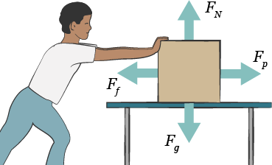Slide
, Fg: weight
•
: slows object down
- Friction,
-degree right angle
a
force, FN: always at
•
Force Diagrams and Abbreviations
- Some common forces are:

  - Push or pull,

counteract | to act against something, causing it to have of an effect
net force | the of all of the forces acting on an object

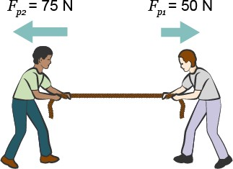Slide
7

Net Force
- The net force is the sum of all of the that act on an object.

  - Positive and negatives have to be assigned for before adding forces together.
  - When assigning positives and negatives to forces, forces pointing to the are positive, and forces pointing to the
are negative.

Label the forces shown as positive (+) or negative (–).

  - The net force in the illustration is .

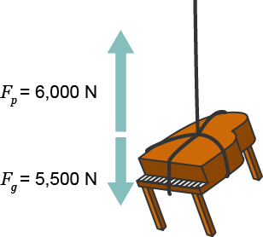Slide
7

Parallel Forces

- Only forces can be added together.

  - Left and can be added together.

  - Up and can be added together.

Label the forces shown as positive (+) or negative (–).

  - The sum of the forces acting on this piano is .

Slide
is no motion. It simply means that there is no change from what is

already happening.
mean there
- It’s important to know that a zero net force does
.
- There is no change in
.
- The net force is
directions are exactly equal:
Balanced Forces

- When forces acting in
10
force.

- Unbalanced forces can start an object moving or stop an object from moving.
as the net
•

- Both speed and direction

- The motion of the object is in the same
•
.
- There is a change in
- The net force is positive or negative in the direction of the

force.
:
Unbalanced Forces

- When forces acting in opposite directions are

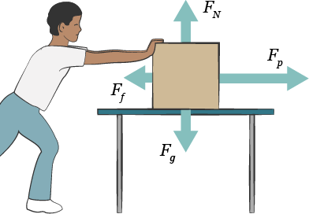Slide
12

Force Diagrams and Unbalanced Forces

- Force diagrams show when forces are balanced or .

  - The length of the vector represents the of the force.

  - The longer the vector is the force there is.

- The net force and the motion will be in the direction of the vector.

Circle the vector that represents the largest force.

How do forces affect the motion of an object?
Lesson Question

Slide
?
, Ff
•
, FN
•
, Fg
•
acting on an object.

- or pull, Fp
of the forces
- Force diagrams show the type, magnitude, and
with magnitude and direction.
- Forces are
is a push or a pull.
- A
Review: Key Concepts
FORCES
Answer
2

Slide
force.
direction of the
- A net force of zero means that all forces are in and there is no change in motion.
- A positive or negative net force causes a change in motion in the
force is the sum of all forces acting on an object.
- The
Review: Key Concepts
NET FORCE
2

Use this space to write any questions or thoughts about this lesson.

