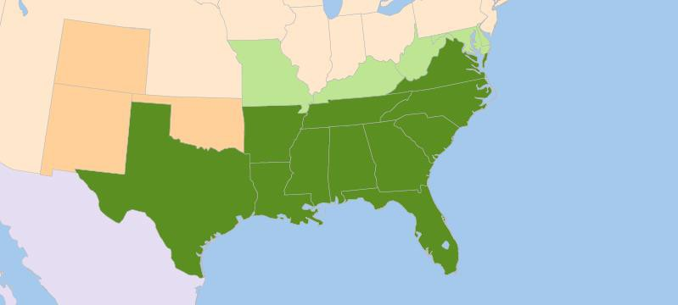
of the Battle of Fort Sumter.
- Explain the
.
- Describe the events that led to the attack on
.
- Contrast the ideas in the inaugural addresses of

and
Lesson Objectives

By the end of this lesson, you should be able to:
FL
LA
TX
GA
AL
MS
SC
AK
MD DE
VA
NC
KY
TN
Indian Terr.
New Mexico Terr.
MO
WV
Colorado Terr.
The Confederate States of America
Circle the 7 states that immediately seceded from the Union after Lincoln was elected president.
Fill in the missing word in the map legend.
Confederate states

states

Territories

W
2K

Words to Know
Fill in this table as you work through the lesson. You may also use the glossary to help you.
one or more large mounted guns.
a speech given on the day the president takes the oath of office; it allows the president to address the people for the first time as the nation’s leader, tells people the president’s goals, and sets a tone for the presidency

- Supported
- Wanted to avoid war
- Was sworn into office in February 1861
- Was president of the
Jefferson Davis
secession
- Would not
war
- Wanted to
- Was sworn into office in March 1861

?
Lesson Question
Slide
2
- Was president of the
Abraham Lincoln and Jefferson Davis

Abraham Lincoln

Slide
presidency
and sets a tone for the
- Lets people know the president’s
- Allows the president to address the people for the

as the nation’s leader
- Given on the day the president takes the
Inaugural Addresses

REAL-WORLD CONNECTION

What is an inaugural address?
2
states had seceded.
- In response,
into the West.
the
- Lincoln’s platform was to
Abraham Lincoln (1809–1865)

Once elected, Lincoln faced a tremendous challenge.

Slide
unless required to do so
- Refused to use
of the Constitution in all states
- Promised to carry out the
interfere with slavery where it
- Stated he would
states.
In his address, Lincoln reached out to
Lincoln’s First Inaugural Address
2
Circle the word that Lincoln says is linked to anarchy (lawlessness).
about the use of force.
- He was
- He wished to avoid war.
.
- He felt he needed to
the issue.
on
Lincoln on Secession

Lincoln refused to accept secession and would not

Plainly the central idea of secession is the essence of anarchy. A majority held in restraint by constitutional checks and limitations . . . is the only true sovereign of a free people . . . The rule of a minority, as a permanent arrangement, is wholly inadmissible.
– Abraham Lincoln, March 4, 1861

Slide
the Union
the seceded states back into
- Feared that Lincoln would
from the Union
- Felt that states had a right to
was in jeopardy with Lincoln as president
- Felt
of war between the states.
Davis was
Jefferson Davis (1808–1889)
4
- Expressed that war was not wanted, but the Confederacy would

if necessary
would take
- Described the form the
Davis’s Inaugural Address

In his address, Jefferson Davis discussed how the would succeed.
- Explained the reasons for

Slide

Davis on Secession

4
Davis believed that the Southern states had the to secede because their government had failed them.
He believed citizens had the right to end their relationship with their government
if they wish.

Circle the word in Jefferson’s speech that means “approval.”

Our present political position has been achieved in a manner unprecedented in the history of nations. It illustrates the American idea that governments rest on the consent of the governed, and that it is the right of the people to alter or abolish them at will whenever they become destructive of the ends for which they were established.

– Jefferson Davis, February 18, 1861

Slide

Fort Sumter

Fort Sumter protected commercial areas of the . In 1860, the fort was under control.
The Confederacy believed it had the right to it.

Circle the location of Fort Sumter, on the coast of South Carolina.

VA
KY

NC
TN

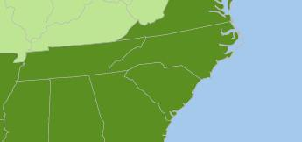
7

MS AL
SC

GA Fort Sumter

Slide
with the South.
war.
Lincoln did not want to appear to be giving into the Confederacy by not resupplying the
fort.
- Resupplying risked
- Lincoln still hoped to
•
- Soldiers were running out of food
and other supplies.
Fort Sumter
secession
Wanted to avoid
war
Needed to
Lincoln’s Challenge
Why was the situation at Fort Sumter a challenge for Lincoln?
7
9
to surrender.
- The Union
.
- It would not hold out much longer without
- The fort was low on supplies and soldiers.
Sumter.
of Fort
The Situation at Fort Sumter

In March 1861, the Confederates demanded the

Slide
- Promised that

would be sent
- Warned Confederates that he was doing this so they would not

the ships
to resupply the fort.
Resupplying the Fort

Lincoln sent
9
12
.
The Civil War had
Fort Sumter on April 13.
The Union
guns.
––large mounted
The fort could not hold up against the heavy
The Bombing Begins
With US naval ships on the way, Confederate troops on the fort on April 12.

Slide
to send troops.
- The states that had seceded
from each state.
- He asked for
After the Bombing

After the bombing at Fort Sumter, Lincoln called for volunteers for the

.
12
- Western delegates from Virginia opposed secession and

.
- Tennessee, Arkansas, North Carolina, and Virginia seceded.
had provoked the conflict.
- Many believed
.
Four More States Secede

After the bombing, four more states

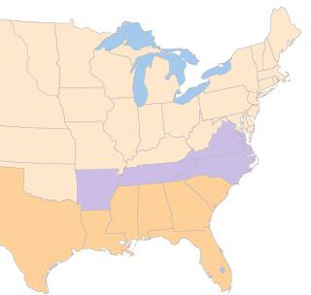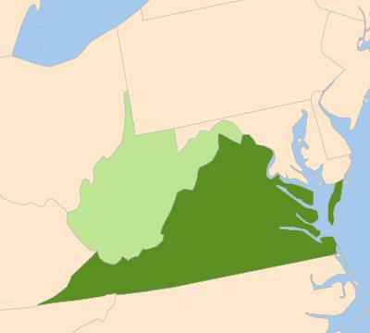Slide
Secession of Southern States

VA
TN NC
AK SC
MI AL GA Jan/Feb
TX LA 1860
FL Apr/Jun
1860

Circle the new state that joined the Union, after rejecting Virginia’s decision to secede.

West Virginia

Virginia
Creation of West Virginia
12
14
that flowed deep into the Confederacy
- Contained
capacity
- Contained almost all of the South’s
- Needed to protect the
in the Union.
The Border States

Lincoln was determined to keep the

Slide

Lincoln declared the goal of the war was to the Union, not to

free people.

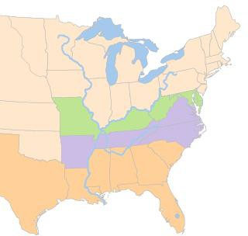
14

Secession of Southern States

Mississippi
River Ohio MD River DE
WV
MO KY
Tennessee River

Border States

Slide

From Secession to War

May 1861
December 1860–February 1861

states secede from

Union

March 1861
Lincoln

more states

inaugurated secede
1860 Jan 1861

14

November 1860

elected

February 1861
Jefferson Davis inaugurated

April 1861

Bombing of

How did the Civil War begin?
Lesson Question
?
Answer

Slide
2

Review: Views on Secession

Abraham Lincoln

- Was president of the

- to recognize secession

- Would not compromise on his secession beliefs

- Wanted to the Union

Jefferson Davis

- Was president of the

- Supported

- Believed the Southern states had every right to leave the Union

Slide
to resupply the fort.
- Lincoln sent
to surrender.
- The Union
demanded the Union surrender the fort.
- The
control.
fort that the Confederacy wanted to
Fort Sumter was a
Review: Causes of the Attack on Fort Sumter
2
.
states to remain in the
Lincoln convinced five key
more states seceded.
•
.
- Lincoln put out a call for
.
- The Union
.
Review: The Attack and Its Aftermath

The Confederate army attacked Fort Sumter on April 12,

Use this space to write any questions or thoughts about this lesson.

