?
W2K
D. a triangle having an interior angle measuring 90 degrees
perfect square
C. in a right triangle, either of the two sides forming the right angle
hypotenuse
B. a number that is the result of squaring a natural, or whole, number
right triangle
A. the side of a right triangle that is opposite the right angle; always the longest side
leg
Words to Know
Write the letter of the definition next to the matching word as you work through the lesson. You may use the glossary to help you.
squares.
Recognize that non- perfect square roots
can be approximated.
Evaluate square
roots of
theorem to solve for the unknown
value.
Use the
Find the hypotenuse of a right triangle.
Lesson Goals
Lesson Question

Perfect Square Numbers
- A number that can be produced by multiplying an integer by is known as a perfect square.

- For example, the number 9 can be produced by multiplying the positive integer 3 by itself: (3 × 3) = 9.

- The number 12, however, cannot be produced this way, so it is not a square.

Are the following numbers perfect squares?

  - 4 = (2 × 2) =

  - 25 = ( × ) = 52

  - 50 = not a perfect square

Slide

Longest Side of a Right Triangle
A right triangle is a triangle that contains one right angle. The sides that make up the right angle are the legs, and the side the right angle is
the hypotenuse. The hypotenuse is always the side of a right triangle.

c2 = a2 + b2

A A

leg
hypotenuse b c

C leg B
2
C a B

Slide

Using the Pythagorean Theorem to Find the Hypotenuse

EXAMPLE
Use the Pythagorean theorem to find the length of the hypotenuse, c.

A Pythagorean theorem: a2 + b2 = c2

24 ft c
72 + 242 = c2
+ 576 = c2

= c2

C 7 ft B
625 = c2

± 25 = c
2

c = ft

Distance is always positive.

Slide

The Pythagorean Theorem and Distance

REAL-WORLD CONNECTION
To get to the local coffee shop, Van left his house, walked 3 blocks south, and then walked 4 blocks west.

Van’s House
3 blocks south

Coffee Shop
4 blocks west

When he got to the coffee shop, Van realized he could take a more direct route home. How many blocks will Van have to walk to get home from the coffee shop if he takes the most direct route?

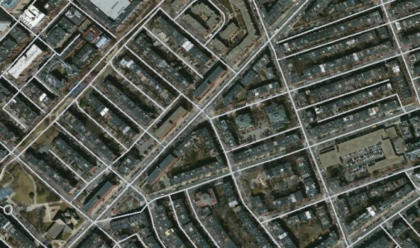
4
a2 + b2 = c2
32 + 42 = c2
+ 16 = c2

= c2

± 25 = c

= c

5 blocks

Slide
± 13 = c
13 = c
C 3 in. B
= c2
+ 4 = c2
= c2
c =
2 in.
32 +
a2 + b2 = c2
A
Finding the Length of a Non-Perfect Hypotenuse
EXAMPLE
Use the Pythagorean theorem to find the length of the hypotenuse, c.
7
10
ft
c ≈
Use a calculator to give an approximate number for the length.
c2
178 =
178 = c
3 ft
9 + ₌ c2
13 ft
c
32 + 132 = c2
Finding the Length of a Ladder
REAL-WORLD CONNECTION
Robert wants to hang a picture above his entertainment center. How long must a ladder be to reach a height of 13 feet if the bottom of the ladder is placed 3 feet from the base of the wall?
a2 + b2 = c2

Slide

Right Triangles and Measures

REAL-WORLD CONNECTION
Jenna is shopping for a new computer monitor. If she knows the measurements of the sides of the monitor, how can she figure out the diagonal measurement?

11 in.

c

14 in.
a2 + b2 = c2
+ 142 = c2

121 + ₌ c2
317 = c2

The diagonal split the rectangle into 2 right triangles.
317

317
= c2
= c

Use the theorem.
12
c ≈ in.

Summary
Lesson Question
??

Finding the Hypotenuse in Right Triangles

How can you find the length of the hypotenuse of a right triangle?
Lesson Question
Answer

Use this space to write any questions or thoughts about this lesson.

