?
Lesson Question
.
- Describe the factors that influenced the election of
.
new
during the Jackson era.

- Explain how the “corrupt bargain” of 1824 led to the formation of a
that occurred
Lesson Objectives
By the end of this lesson, you should be able to:

- Identify the changes in democratic
The State of US Democracy in 1820
Before 1820, only
who owned
and paid
could vote.
Political parties
There were no official
parties.
whom they were voting
Voting
llot.
Electoral College
lawmakers chose representatives for the

Electoral College, who then elected the .
Voter participation was less than
percent of
Participation
adult white males.

Men voted by
for, not by |  |  | ba

2
.
- Most states gradually extended the vote to all
requirements for voting.
- They demanded an end to
them.
- People wanted to be able to elect politicians who would
.
and
- Many people lost their
crisis swept the country.
In 1819, an
The Panic of 1819 and New Voting Rights
crisis.
That changed when the country experienced an
to voters.
- Candidates did not appeal
, powerful families.
- Voters followed the lead of
.
- Voting rights were
.
American Democracy Before 1820

had a small role in

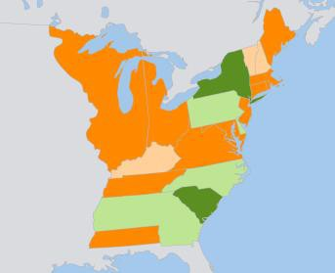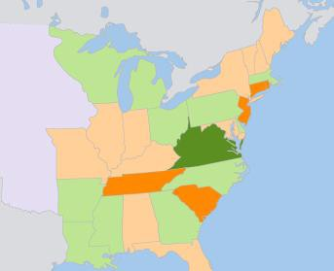
2

The Growth of Voting Rights

By 1830, most had the right to vote.

1800
None
Qualifications

Property or

Property and

1830

4
6
Other Changes to the Voting Process
- Popularly elected members of the
nominations
•
ballots
•
polling places
•
Voting Today
REAL-WORLD CONNECTION
Today, we still use some of the voting processes that began in the 1820s.

Polling Places | More places were created, and they stayed  open .
Written Votes | Voters no longer their votes. They  them down.
Nominations | Public were held to nominate candidates.
Electorates | Members of the Electoral College were chosen by  vote.

8
”
- Spoke out against an “
- Defeated the British at the Battle of
- Became a lawyer and politician in
- Was captured during the
Andrew Jackson (1767–1845)

- Was born in the
- Others were tired of the well-connected politicians.
candidates.
- Some resented the selection process for
.
- Its leaders disagreed about
Party was split:
The
Party had collapsed.
- The
.
, the US went back to having only one official
US Politics Before 1824

After the

8
in 1824
in 1821
- Senator
- After returning to Senate,
nominated for
- Governor of
- Tennessee’s first
- Tennessee
Candidate
Governor
Member of Congress
Delegate
Jackson’s Early Political Career

Jackson rose through the political ranks.
.
These traits won him the nomination for
- A well-connected champion of the
- A hot-tempered
hero
and
- A
birth
- A
popular.
reputation made him
background and
Jackson’s
Jackson’s Cult of Personality

10
John Quincy Adams vs. Andrew Jackson

Of the four candidates for president, and
were the
most popular.
streak
with an
- Was a
man
but
- Considered to be a
and politician
- Served as a
John Quincy Adams (1767–1848)

- Was the son of President

John Quincy Adams | Andrew Jackson
- Favored a federal government  - Supported on imports  - slavery  - Disliked politics | - Favored the rights of the and the “common man”  - Opposed tariffs  - Was a slaver and slavery

12
.”
Jackson accused Adams and Clay of making a “
for Adams.
.
.
collected
Adams made Clay
Adams won the
Henry Clay
election.
decided the
The “Corrupt Bargain” of 1824

Because no candidate won a majority of votes,
Vote
Vote
J.Q. Adams Jackson Crawford
Clay
38%
43%
32%
16%
31%
14%
J.Q. Adams Jackson Crawford
Clay
13%
13%
vote.
The Election of 1824

Four men ran for president in 1824. None won a

15
17
unsuccessful.
with the West Indies were
- His efforts to increase
failed.
- His attempts to acquire
policies were unpopular.
- His
were blocked.
- His measures to increase
as a president.
In his own mind, Adams had
The Presidency of John Quincy Adams
for support.
- Jackson’s campaign appealed directly to the
.
- They formed a new political party: the
.
- He fought Adams’s
”.
- He called Adams an “
Jackson Fights Back

Jackson felt betrayed by Clay’s deal.

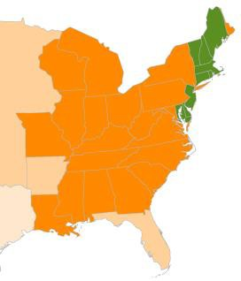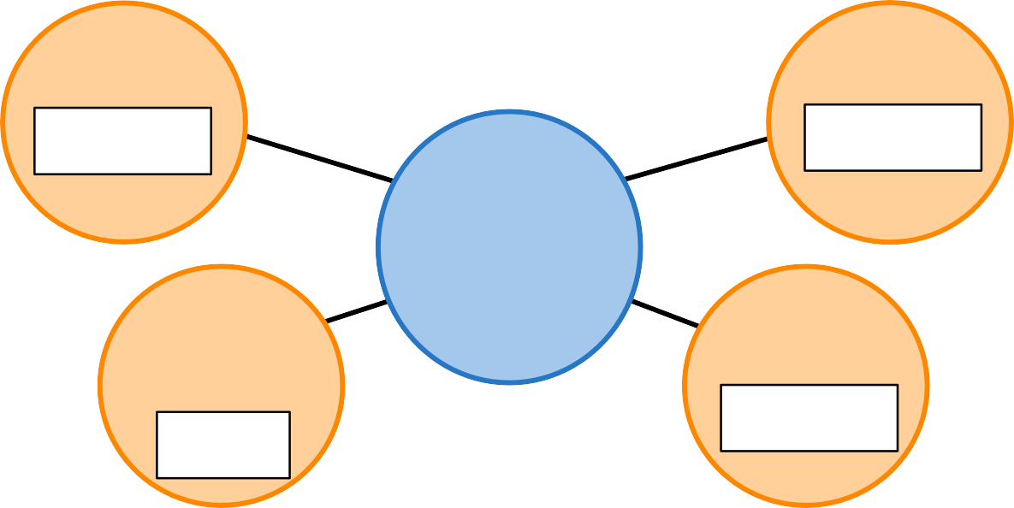
17
Popular vote
Electoral vote
1828
.
, and he won by a
Jackson’s campaign was
.
Jackson Wins the Election of 1828

Adams had become
class
First president from the
The first president from the
Jackson’s election
education
campaign
One of the few with a
The first
to use a
What Jackson’s Election Meant for America

How did American democracy change in the 1820s?
Lesson Question
?
Answer

2
Party to run against Adams in 1828.
” and formed the
- Jackson called this a “
collected votes for him.
- Adams won the election after
election.
in the 1824 presidential
- He ran against
rose to political fame.
Review: The Election of 1824

- War hero
Slide
was opened to voters.
candidates for
- The process of
.
and more
- Voting became
.
- Most states gave the right to vote to all
requirements.
of 1819 led to changes in
- The
Review: The Expansion of Voting Rights

Slide
2
background.
, and the first from a
- He was the first president from the
the 1828 election by a landslide.
- He
”.
- He attacked Adams as an “
to voters for support.
appealed
became the first candidate whose campaign
•
Review: The Election of 1828
Use this space to write any questions or thoughts about this lesson.

