Words to Know
Fill in this table as you work through the lesson. You may also use the glossary to help you.
Lesson Question
?
W
2K
.
using
explanations.
Evaluate scientific arguments
Analyze
Lesson Goals

claim | a statement saying that what is presented is
peer review | the by which the quality of a scientific  research paper is by other scientists in the same field

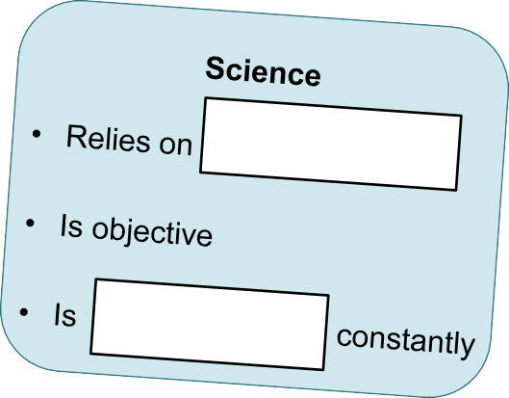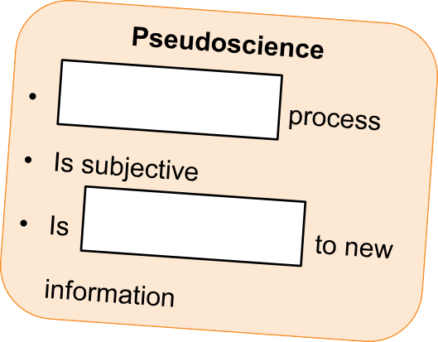

Science vs. Pseudoscience

Slide
.
- based on multiple
experiment.
- from a
that is:
Scientific claims are
.
is
saying that what is presented
is a
A
Scientific Claims
2
supporting the claim?
is the information
and
- How
of the claim?
- What is the
?
- What is the
answer these questions.
, you should be able to
To determine if a scientific claim is
Evaluation of Claims

Slide
2

Claims about Caffeine: Example
Step 1: Identify what is being stated as a fact.

- Claim: Caffeine improves mental and motor

.

Step 2: Determine the importance of this claim.

- Importance: People drink caffeinated drinks to help them in the morning or to alertness.
Step 3: Ask: how accurate and consistent is the information supporting this claim?

- Accuracy and consistency: This study was from a university research study. The study shows for all ten subjects, the average time to fit
the beads on the pegs . This shows that caffeine a person’s fine motor skills.

If the information supporting the claim is factual from a reliable reference, you

know that the information is and .

Slide
4

Scientific Claims

Assessing a claim requires you to look at its .

- How will the information ?

This information could be used by manufacturers or by people who want to avoid BPA.
- Who may from the claim?

Someone who can benefit financially may use the data to help promote a . In this example, manufacturers who produce containers that do not contain BPA could sell lots of new containers.
On the other hand, it may also be used by an organization that wants to promote the well-being of fetuses, infants, and children and
them from being exposed to

substances.

- How does the claim to you?

If it doesn’t relate to you, you may the claim. However, if you drink from containers that are made using BPA, you may want to pay closer to this.

Slide
source.
from a
by
as well, as it is supported
The claim is probably
.
National Institute of Health. The information is
was published by the US Department of Health and Human Services,
a scientific publication aimed at general audiences. In this case, the story
A story from a celebrity magazine might be quite different from a story in
?
did you read the information? Is the source
•
4
7
of the profession
- Helps ensure
- Allows others in the field to judge
is one way to ensure that data can be trusted.
collect data.
used to
The quality of a scientific claim depends on the
from a controlled experiment.
by data that are based on multiple trials
Scientific claims are
Quality of Scientific Claims

7
- Direct
conclusions
•
of
- Identify
the standards of the field
•
Reasons for Peer Review
Accept
Slide
in that field
paper
Paper becomes part of the
Journal
reject it, or return it for

revisions
for
Reject
accept paper,
Journal distributes paper to
Author submits

to journal

(Cycle may repeat)
The Peer Review Process

Slide
.
scientific claim is
by multiple tests, the evidence supporting a
source and the results are
- If data are from a
on the subject?
- Is the source an
of the source?
- What is the
did the data come from?
•
Sources of Data
11
Reliable vs. Unreliable Sources  Reliable Sources  - scientific  journals  - Encyclopedias  - Nonfiction books written by  - websites  and publications | Unreliable Sources  - websites and  blogs  - Online encyclopedias edited by the  - Magazines and newspaper  - Books written by  - Advertisements

How are scientific explanations evaluated?
Lesson Question

Slide
?
by peer review
- Can be
.
- Quality depends on
is reliable.
, the evidence supporting a scientific claim
by
and the results are validated
If data are from a
Review: Key Concepts
Answer
2

Use this space to write any questions or thoughts about this lesson.

