?
W
2K
Words to Know
Fill in this table as you work through the lesson. You may also use the glossary to help you.
Examine the movement of energy through food chains and food webs.
Identify producers, consumers, and

in food chains and food webs.
Analyze the transfer of energy through the trophic levels of an energy pyramid.
.
Explain the roles of producers, consumers, and decomposers in an
Explore energy flow within an ecosystem.
Lesson Goals
Lesson Question

the position of an organism in a food web or energy pyramid
an organism that makes its own food; also called a producer
an animal that eats both plants and animals
an organism that eats other organisms; also called a heterotroph

W
2K
Words to Know
plants and then to animals that eat those animals.
that eat
stored in plants is passed on to
- The
dioxide + water � glucose+
•
Photosynthesis
- Green plants and some other organisms make food through photosynthesis.

an animal that eats only plants
a diagram illustrating the amount of energy available at each feeding level in an ecosystem
a model that shows the feeding relationships between organisms in an ecosystem
a model that shows the interconnected food chains in an ecosystem
an organism that breaks down waste and dead organisms
an organism that eats other organisms; also called a consumer
an animal that only eats other animals
an organism that makes its own food; also called an autotroph

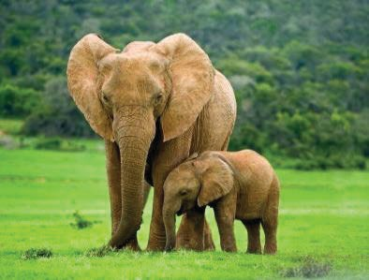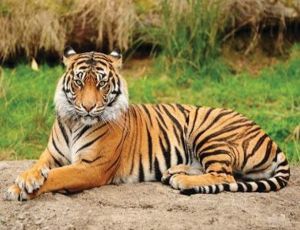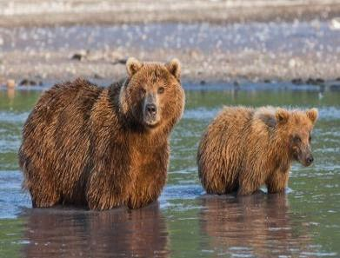
2
4
eat
both plants and animals.
eat other animals.
only eat plants.
only
Consumers
A consumer is an organism that eats other organisms; it is also called a
.
back into the environment
- Recycles
and dead
Decomposers
- A decomposer is an organism that breaks down organisms.
Slide
Producers
- A producer is an organism that makes its own food; it is also called an
.

  - Converts energy from the sun into food energy through

  - Creates all usable food energy on the planet

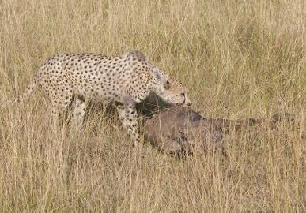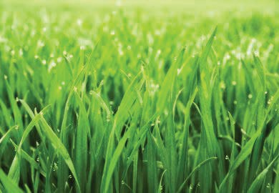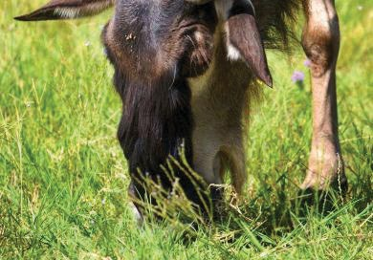Slide
consumer
consumer
relationships between organisms in an
Food Chains
A food chain shows the ecosystem.
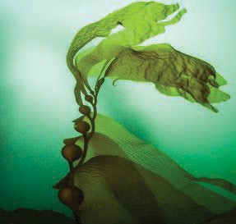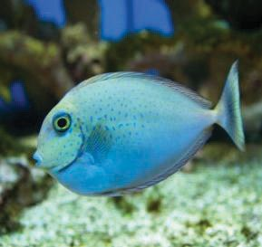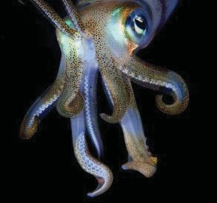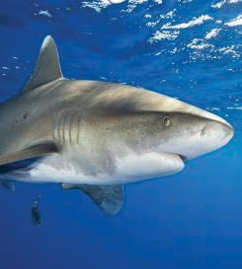
7
Circle the consumer in the image that will overpopulate with the removal of squid.
consumer
Secondary consumer
Primary consumer
Producer
in the chain.
from a food chain, it affects all of the
If one organism is

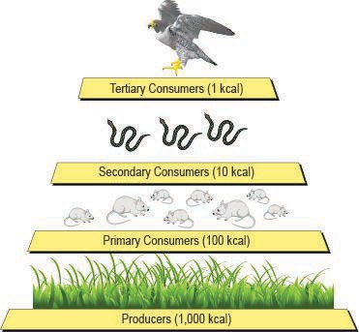
9
12
available at each feeding level in an ecosystem.
- The position of an organism in a food web or energy pyramid is called a
level.
is a diagram illustrating the amount of energy
- An energy
Energy Transfer in Ecosystems
.
energy is used in

processes or is lost as
of the
- The remaining
at one trophic level is passed on to organisms at the next trophic level.
Draw an arrow to show the direction of
of the energy energy transfer in the energy pyramid.
- Only about
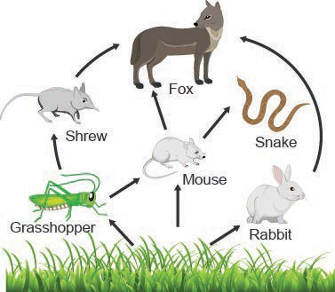Slide
- can follow several
different paths in a food web.
.
an
in
Circle the producer in the food web.
Food Webs
- A food web shows the interconnected food

?

How does energy flow through an ecosystem?
Lesson Question

Slide
break down waste and dead organisms.
•
, eat other organisms to get the energy
Consumers, or they need.
•
, convert energy from the sun into food
Producers, or
energy through photosynthesis.
•
Review: Key Concepts
- Energy enters an ecosystem in the form of sunlight.
Answer
2

Slide
- Only about 10% of the energy at one trophic level is passed on to organisms at the next trophic level.
- The remaining 90% of the energy is used in life processes or is lost as
.
pyramid illustrates the amount of energy available at each
An
trophic level.
•
.
- A food web shows interconnected food chains in an
relationship between organisms in an
A food chain shows the ecosystem.
•
Review: Key Concepts
2

Use this space to write any questions or thoughts about this lesson.

