?
.
Understand
the use of words with strong
Analyze the word
choices a writer makes.
meanings of words.
Examine the reasons that an author chooses
to use certain words.
Identify both
the dictionary definitions and
Lesson Goals
Lesson Question

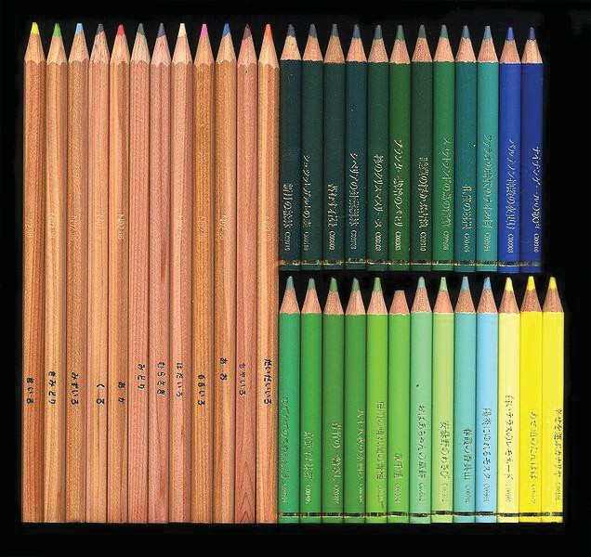
W2K
D. the feelings or shades of meaning associated with a word
purpose
C. a logical persuasion
denotation
B. a word’s dictionary definition
argument
A. a reason for writing
connotation
Words to Know
Write the letter of the definition next to the matching word as you work through the lesson. You may use the glossary to help you.
.
for the different
- Each pencil color has a
pencils could be called blue.
•
pencils in this pack could be called green.
•
Shades of Colors

Shades of Meaning

A word’s definition
is called its denotation.

- Denotation is the meaning of the word.
- One word can have several denotations.
The or shade of
meaning associated with a word is called its connotation.
- Words with the same denotation can have different connotations.
- Connotations can be positive, negative, or .

2

Different Ways of Being Loud

Loud

Ear-splitting

Slide
Nosy
Interested
emotions that are
or
Connotations often include associated with a particular word.
Curious
Emotions and Connotations
4
8
- to describe.
.
- to investigate.

- to
.
- to persuade.

- to
.
- to
Purposes for Writing
Writers can have many different purposes for writing. Some purposes are:

Slide
It is vitally important to brush your teeth two times a day. If you do not, it can have embarrassing consequences for your teeth and horrible effects on your health.
Everyone should brush their teeth at least two times a day. Studies show that more frequent brushing, especially after every meal, leads to fewer cavities.
.
persuasion involves
, and
something or do something. Argument relies on
the reader to
Arguing vs. Persuading

Argumentative and persuasive texts try to
8
10
When I learned that the children in the refugee camp had no access to dental care, I wondered what impact it would have on their health. I learned that both their teeth and their overall health were affected.
There are health risks associated with not brushing your teeth. Bad breath and cavities are the most common and usually the first to appear.
information, while investigative text
Informative text
a question or problem.
.
Informative vs. Investigative

Informative and investigative texts both provide the reader with

Slide
The pain in my tooth was piercing. Waves of agony rolled out from my jaw, across my entire head, and even down my neck.
My first visit to the dentist did not come until I was twelve. I stepped slowly into the room, terrified by the shiny implements that would probe my neglected teeth.
a
, while descriptive text
Narrative text tells a
person, place, or event.
.
Narrative vs. Descriptive

Narrative and descriptive texts both tell the reader about
12
15
.
- Remember that different types of writing will use different types of
.
to figure out the author’s purpose for
- Look for the
.
Determine the writer’s
Analyzing Word Connotations: Step One

Slide
synonym for the word change the
Does substituting a
effect of the sentence?
•
- Do any of the words have a negative or positive associated with them?
with other words or topics?
- Are any of the words
Analyzing Word Connotations: Step Two
Look for words with strong connotations.
Read the text carefully, and ask yourself these questions:
127
19
that this is not commonly done in the United States.
It is
used. How does a neutral word change the sentence?
a neutral word in place of the word
- For help, try
- What effect does the word have on the reader?
the word?
- Why did the author
of these words.
Think about the
Analyzing Word Connotations: Step Three

Summary Connotation and Denotation
?
How do words with strong connotations help authors achieve their purpose?
Lesson Question
Answer

Use this space to write any questions or thoughts about this lesson.

