Words to Know
Fill in this table as you work through the lesson. You may also use the glossary to
help you.
formulate conclusions.
graphs.
and
data from charts and
Examine data to draw
in
Predict
.
Analyze data to determine their validity and
Lesson Goals
Lesson Question
?
W
2K

qualitative data | a type of non-numerical, data
quantitative data | a type of data that can be measured

.
the results.
- Replication should produce the
and increases confidence in
- Repetition
results.
- Good design and repeatability ensure
follow a similar method.
Experimental Design Principles

- Different
.
- Reproducibility is the ability of data to be
measured values.
to other
- Precision is the closeness of
accepted value.
is the closeness of measured values to the
•
.
- Data must be reliable and

Slide
to reproduce data.
- the
.
- measurement or recording
data.
•
data.
•
data may result from:
•
scientists.
and reproduced by the researcher and other
Valid vs. Invalid Data

- Valid data can be
2
4
.
data that can be
data are
•
but not measured.
data can be
Data Analysis

•

.
Slide
____ analyze
E. a visual representation of data
____ linear
D. to examine in detail
C. the likelihood that a given event will occur
____ graph
B. forming a straight line
____ probability
A. not forming a straight line
____ nonlinear
Words to Know
Write the letter of the definition next to the matching word as you work through the lesson. You may use the glossary to help you.
7
data.
.
Draw
data.
.
Collect
Data Analysis
Write the correct phrase into the boxes in the flow diagram.

Slide
in a variety of ways
•
complicated facts
•
is a visual representation of data.
A
Types of Graphs
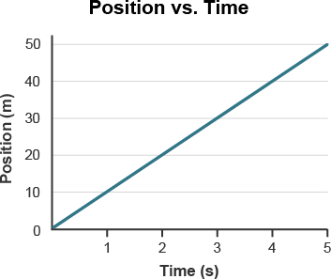
7
- This graph shows a linear relationship between the position of the object
and time. Based on the pattern shown here, you could predict that the object will continue moving at a rate of 10 m/s.
.
or
They may be
.
- The 𝑦-axis shows what is being
.
- The 𝑥-axis displays
Line Graphs

graphs show changes over a period of time.

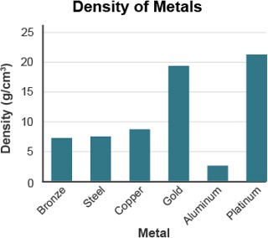Slide
9

Bar Graphs

graphs quantities for particular categories.

- Used to see quickly

- This graph compares the density of different metals. The higher the bar, the more dense the metal.

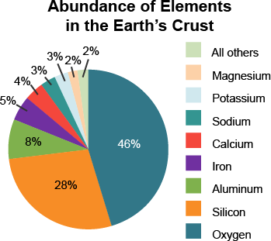Slide
9

Pie Graphs

graphs show the relationship among .

- In this pie graph, the color of each “slice” relates to an element in Earth’s crust. Using the pie graph, it is easy to see that oxygen is the most abundant element in Earth’s crust.

Slide

Scatterplots

show the between two sets of data.

12

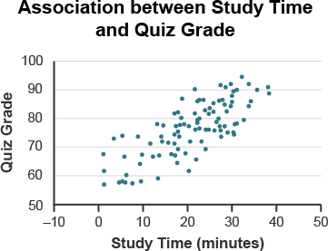 | 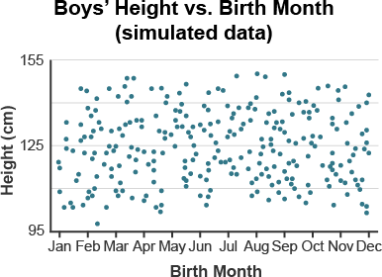
This scatterplot shows a direct relationship between time spent  studying and quiz grade. | This scatterplot shows that there is no relationship between boys’ height  and birth month.

Slide

Histograms

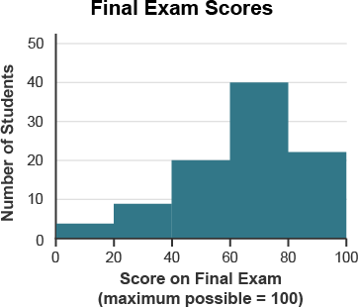
12

represent the of data.

  - Groups numbers into

  - This graph shows the final exam scores of students in in a physical science class. Each bar represents a score range, such 0–20%, 20–40%, and so on. About 20 students scored between 40–60% on the final exam. Most students (about 40) scored between 60–80%.

Slide

Frequency Distributions

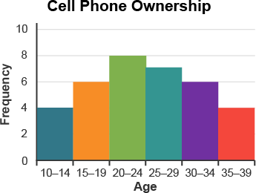
12

group data into and

show how often occurs. Both the table and the histogram show the same frequency distribution.
Age | Frequency
10–14 | 4
15–19 | 6
20–24 | 8
25–29 | 7
30–34 | 6
35–39 | 4

Slide
2
when flipping a coin is ¹.
Because a coin has two sides—heads and tails—the probability of getting tails
number of outcomes
Probability =
outcomes
Number of
that a given event will occur.
is the
Probability
15
likely
Likely
1
1
2
Unlikely
0
More likely
Less likely
Probability: Number Line

Probabilities have a value between 0 and 1.

Slide

Probability: Example
GUMBALL MACHINE

  - What is the probability of getting a yellow gumball?

Number of desired outcomes Total number of outcomes

Step 1: Count the number of yellow gumballs in the machine: .

Step 2: Count the total number of gumballs in the machine: .

Step 3: Solve using the probability equation: .

Step 4: Analyze the likelihood of getting a yellow gumball: Since 1
10
is between 0

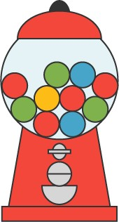and 1
15
2
, it is unlikely that you will get a yellow gumball.

Why are data analyzed?
Lesson Question

Slide
?
data.
, or the inability to reproduce
measurement or recording
data may result from inadequate data, false data,
•
and other scientists.
by the researcher
- Valid data can be verified and
Review: Key Concepts
VALID AND INVALID DATA
Answer
2

Slide
show how often a particular value occurs.
and
data into
- Frequency distributions
of data.
- Histograms represent the
- Scatterplots show the relationship between two sets of data.
.
of
- Pie graphs show the relationship among
for particular categories.
- Bar graphs
.
- Line graphs show
Graphs are visual representations that display data in a variety of ways.
Review: Key Concepts
GRAPHS
2
2
- 1 = certain
- 1 = equally likely
- Values between 0 and 1
  - 0 = impossible
Total number of outcomes
Probability = Number of desired outcomes
•
that an event will occur.
Review: Key Concepts
PROBABILITY

is the

Use this space to write any questions or thoughts about this lesson.

